**BUDDYDOME**

**A PROJECT REPORT**

***Submitted by***

**Tapas Singhal 21BSA10146**

*in partial fulfillment for the award of the degree*

*of*

**BACHELORS OF TECHNOLOGY**

*in*

# **COMPUTER SCIENCE AND ENGINEERING**



**SCHOOL OF COMPUTING SCIENCE AND ENGINEERING**

**VIT BHOPAL UNIVERSITY**

**KOTHRI KALAN, SEHORE**

**MADHYA PRADESH – 466114**

**VIT BHOPAL UNIVERSITY, KOTHRIKALAN, SEHORE**

**MADHYA PRADESH – 466114**

**BONAFIDE CERTIFICATE**

Certified that this project report titled **“BUDDYDOME ”** is the bonafide work of Tapas Singhal who carried out the project work under my supervision. Certified further that to the best of my knowledge the work reported at this time does not form part of any other project/research work based on which a degree or award was conferred on an earlier occasion on this or any other candidate.

**PROGRAM CHAIR PROJECT GUIDE**

VIRENDRA SINGH KUSHWAH DR. C.P. KOUSHIK

Assistant Professor Assistant Professor Grade 1

SCSE SCSE

VIT BHOPAL UNIVERSITY VIT BHOPAL UNIVERSITY

The Project Exhibition II Examination is held on ***14/02/2023***.

**ACKNOWLEDGEMENT**

First and foremost I would like to thank the Lord Almighty for His presence and immense blessings throughout the project work.

I wish to express my heartfelt gratitude to Dr Virendra Singh Kushwah, Head of the Department, School of Computer Science for much of his valuable support and encouragement in carrying out this work.

I would like to thank my internal guide Dr. C.P. Koushik for continually guiding and actively participating in my project, giving valuable suggestions to complete the project work.

I would like to thank all the technical and teaching staff of the School of Aeronautical Science, who extended directly or indirectly all support.

Last, but not least, I am deeply indebted to my parents who have been the greatest support while I worked day and night for the project to make it a success.

**ABSTRACT**

A well-designed student’s study portal will help the user to get access to different backend resources One of the major challenges is to build a student study portal which is updated regularly with the latest information and also is ready to adapt to the increasing services the redesigning of portal content can help to improve technologies that provide in the portal We are hosting our Project (Student Study Portal) on Cloud Due to which we will also get the advantages of cloud. Our project is user oriented.

**TABLE OF CONTENTS**

|  |  |  |
| --- | --- | --- |
| **CHAPTER NO.** | **TITLE** | **PAGE NO.** |
| 1 | **CHAPTER-1:**  **PROJECT DESCRIPTION AND OUTLINE** Introduction 1.2 Motivation for the work  1.3 [About Introduction to the project  including techniques]  1.5 Problem Statement  1.6 Objective of the work  1.7 Organization of the project  1.8 Summary | .  .  . |
| 2 | **CHAPTER-2:**  **RELATED WORK INVESTIGATION**  2.1 Introduction  2.2 Existing Approaches  2.3 Limitations of existing Approaches  2.4 Summary |  |

|  |  |  |
| --- | --- | --- |
| 3 | **CHAPTER-3:**  **REQUIREMENT ARTIFACTS**  3.1 Introduction  3.2 Software requirements  3.3 Specific Project requirements  3.4 Summary |  |
| 4 | **CHAPTER-4:**  **DESIGN METHODOLOGY AND ITS NOVELTY**  4.1 Methodology and goal  4.2 Functional modules design and analysis  4.3 Subsystem services  4.4 System Designs  4.5 User Interface designs.  4.6 Summary |  |
| 5 | **CHAPTER-5:**  **TECHNICAL IMPLEMENTATION & ANALYSIS**  5.1Outline  5.2 Technical coding and code solutions  5.3 Working Layout of Forms  5.4 Performance Analysis  5.5 Summary |  |
| 6 | **CHAPTER-6:**  **PROJECT OUTCOME AND APPLICABILITY**  6.1Outline  6.2 key implementations outlines of the System  6.3 Significant project outcomes  6.4 Project applicability on Real-world applications  6.4 Inference |  |
| 7 | **CHAPTER-7:**  **CONCLUSIONS AND RECOMMENDATION**  7.1Outline  7.2 Limitation/Constraints of the System  7.3 Future Enhancements  7.4 Inference |  |
|  |  |  |

**Chapter-1: Project description and outline**

1.1 Introduction

Our project is based on Django in which we are developing a Learning Management System.

This project idea is to provide more advanced tools and functionalities to the learning website.

This is a learning and open website for the cloud that can be used by anyone.it has many levels. This website can be used by people having zero knowledge to those who have intermediate level advanced knowledge. We will host it on the cloud, so that we will also get the advantages of the cloud.

1.2 Motivation for The Work

Our team decided on this project because there is no efficient solution right now in any learning website for discussing our doubts/problems. We cannot discuss any topic among ourselves in any website but we have added a discussion page in this website Where we can discuss on any topic, connect with community experts. Here users can post their blogs and can also see other's blogs. This thought gave us the motivation to build a more efficient Learning Management System, which can increase our cloud related learning skills.

1.3 Introduction to The Project

So, our team decide to work on “BuddyDome”. This website is a Leaning website for cloud. This is an open website; anyone can use it for cloud learning. BuddyDome is an open website which can be run by any user on any browser.

## 1.4 Problem Statement

## The objective is to overcome the problem related to the lack of contribution and discussion problems related to any cloud related topic.

## 

## 1.5 Objective of The Work

## This website provides an engaging student experience with a single point of access and hub to all applications, information, and content.

There is a lack of contribution and problem in knowledge sharing in learning websites. Any user can provide learning videos, learning content and blogs and send his content to the website. There are very few websites for cloud learning so this will be very helpful.

1.6 Organization of The Project

The project is organized in the following manner: -

1. Designed a rough sketch of our website “BuddyDome”.

2. Distributed roles for different work from making a model to writing a code.

3. Made a testing version of the website for analysis.

4. After analyzing & collecting required data we started working on final model of website

5. Finally done with practical application in real time.

1.7 Summary

In this section we explained about our project named “BuddyDome”, which is a cloud-based learning website. A well-designed learning website will help the user to get access to different backend resources One of the major challenges is to build a learning website. Which is updated regularly with the latest information and also is ready to adapt to the increasing services the redesigning of website content can help to improve technologies that provide in the website.

We cannot discuss any topic among ourselves in any website but we have added a discussion page in this website Where we can discuss on any topic, connect with community experts. Here, users can post their blogs and can also see other's blogs.

**Chapter-2: Related work investigation**

2.1 Introduction

As we know many websites will be available that will provide us with different kind of sources for learning and very few of them are properly available foe new emerging technologies and updates of the cloud with dedicated sites to explore the possibilities of cloud computing & learn how it is working on from its base structure to fundamentals

2.2 Existing Approaches

With the recent existing approaches user can browse through different cloud learning courses and can enroll and start in it or browse through different sites for courses and events to follow up their path

2.3 Limitations of existing Approaches

The limitation of current existing approaches is the user will be unable to find the correct path for them and to know on which level they must start their course in which state they are currently to how far they want to learn and implement it in their work or regular life. Same goes on with the learn of events and participation in it it willl be a tedious task for user

2.4 Summary

So for hustle free interactions and analysis quiz to know your cloud level to plan your path with us Buddydome provides you with all the necessary features and event deatils and courses in a single website

**Chapter-3: Requirement Artifacts**

3.1 Introduction

This Student study portal Project is created using HTML, CSS in the frontend and designing. There is an admin and user side. All management can be handled by the administrator, such as managing the courses , its levels, checking and managing the course request. The backend is done by PostgreSQL database, AWS, Filezila.

3.2 Software requirements

* Pycharm
* Django
* HTML / CSS
* JavaScript
* Language: Python 3.8 Environment
* AWS Account
* Web Browser: Any of Mozilla, Microsoft Edge, Google Chrome, etc.
* Filezila

3.3 Specific Project requirements

Our Project doesn’t have many specific requirements any user can log in to our website and start their cloud journey on it from a Beginner Level to Professional one.Buddydome provides us different types of methods and analogy to do it.

3.4 Summary

This website provides an engaging student experience with a single point of access and hub to all applications, information, and content.There is a lack of contribution in learning websites. There is also a problem in knowledge sharing in learning websites.

**CHAPTER-4: DESIGN METHODOLOGY AND ITS NOVELTY**

4.1 Methodology:

Understanding the objectives of the portal, target audience, and their needsUser research: Analyzing the behavior of potential users to gain insights into their study habits and preferences. Information architecture: Organizing and structuring the information and content to be included in the portal in a logical and user-friendly manner.User experience design: Designing the interface and user flow, creating wireframes, and prototypes to visualize the portal's functionality.Visual design: Developing the visual style and design elements of the portal, such as typography, color, and graphics.Development: Building the portal, integrating the necessary technology and features, and testing it to ensure it meets the requirements and provides a smooth user experience.Deployment and maintenance: Deploying the portal and performing regular maintenance to keep it up-to-date and secure.

It is essential to follow a user-centered design approach, ensuring that the portal is designed with the end-user in mind, and their needs and preferences are met at every stage of the design process.

4.2 Functional modules design and analysis:

We provide different modules such as profiles, events, quizzes, courses, discussions, blogs, curriculum, contributors, and community on our website which can be accessed by user after sign up and log in to our website.

* Profile: When a new user will sign up to our website they have to provide a spceified role they want to enroll on like the employee or student based on what they want
* 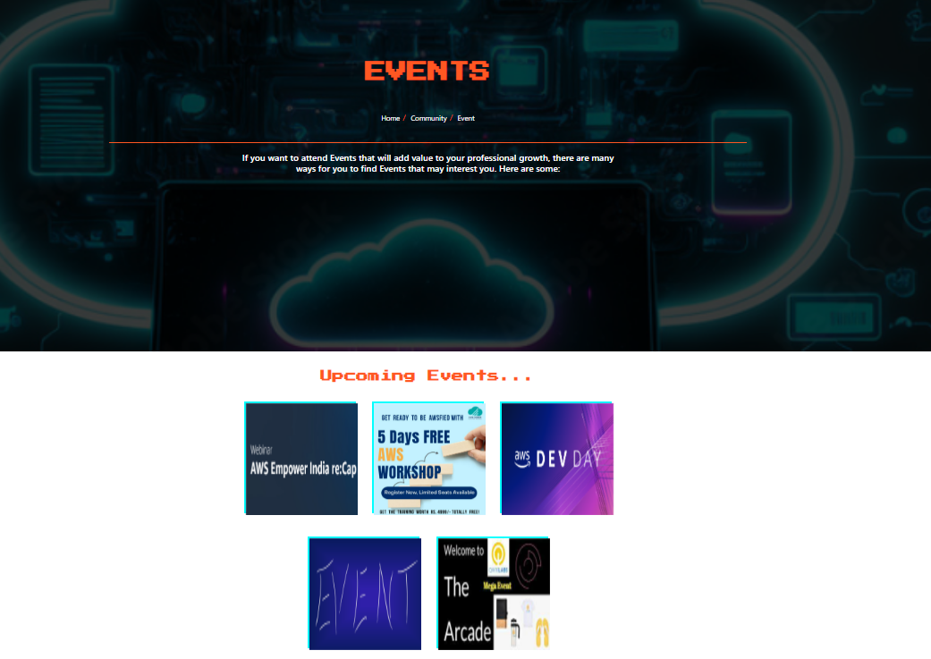Event: Here user will be able to find different events that are going on This module will have a simple explore feature where the users will be able to see various upcoming events where they can participate and learn many things
* GuideBuddy: Here we provide a QUIZ for user to know their CLOUD level with a specified cloud role and learn according to it with the level they are on and what next steps they have to follow and work on with a instructed guides and pattern for their cloud journey.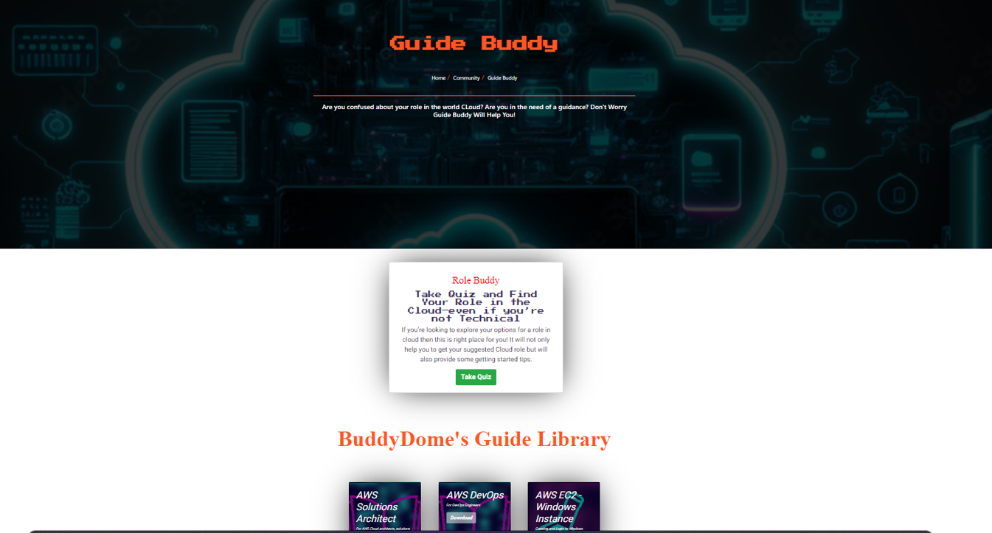
* Courses:The courses offered our website can be arranged in several ways, including:

1. By subject matter: Courses can be grouped into categories based on their subject matter, such as cloud computing fundamentals, architecture, security, and more.
2. By level of difficulty: Courses can be arranged based on the level of difficulty, from beginner to advanced, to ensure that users can progress from one level to the next as they gain more experience.
3. . Certification: Courses can be grouped by the type of certification they offer, such as AWS Certified Solutions Architect or Google Cloud Professional Cloud Architect.

It's crucial to have a well-organized and easy-to-use course catalog to ensure users can quickly find the courses they need and have a seamless learning experience.

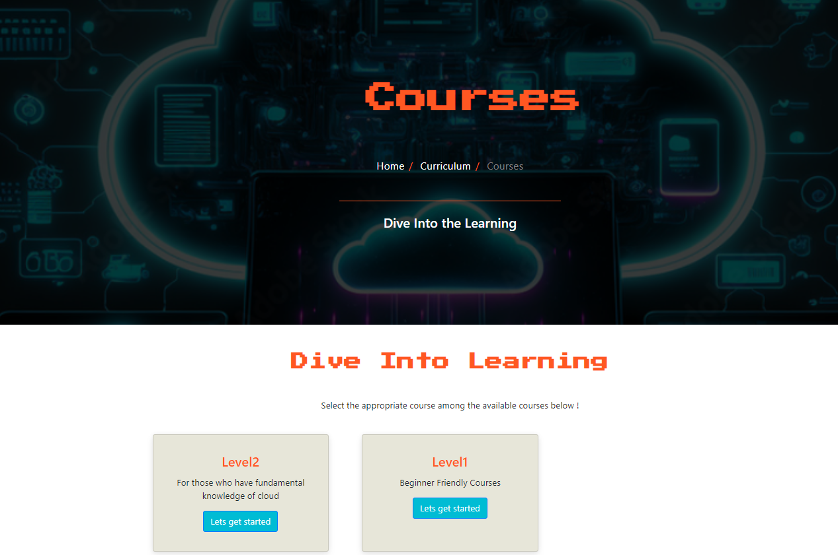

* Community Connect: In this module users have discussion feature with different users from our website using a chat application to communicate with them.in to facilitate interaction and collaboration among users.

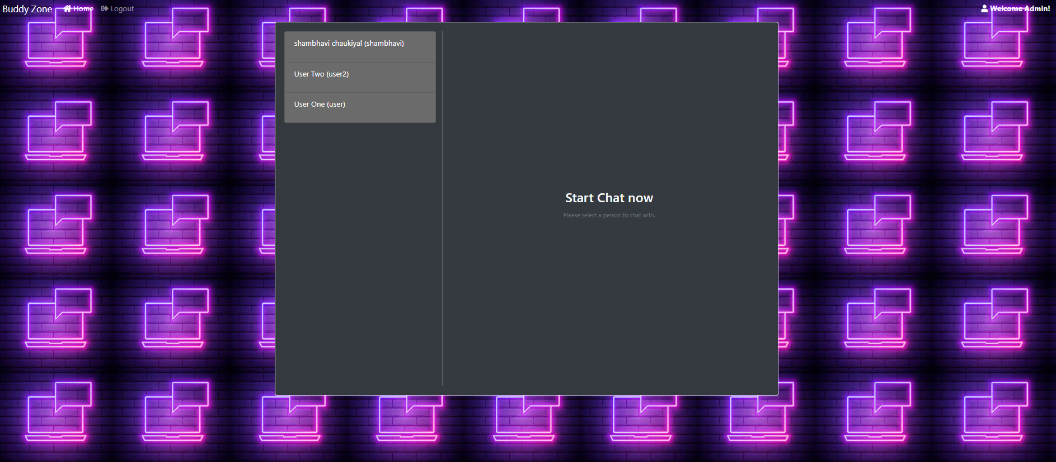

* Blog: A blog is a feature that can be included in to provide users with helpful resources, such as tutorials, tips, and news related to cloud computing. A blog can include Tutorials: Step-by-step guides and tutorials on various cloud computing topics, such as deployment, security, and optimization.News: Latest news and updates on cloud computing, such as new product releases, industry trends, and technology innovations.Tips and tricks: Practical tips and tricks to help users make the most of their cloud computing experience.Opinions and insights: Blog posts that offer opinions and insights on various cloud computing topics, such as cloud migration, cost optimization, and security best practices.

A blog can provide valuable resources to users and encourage them to stay engaged with the portal and continue learning about cloud computing.

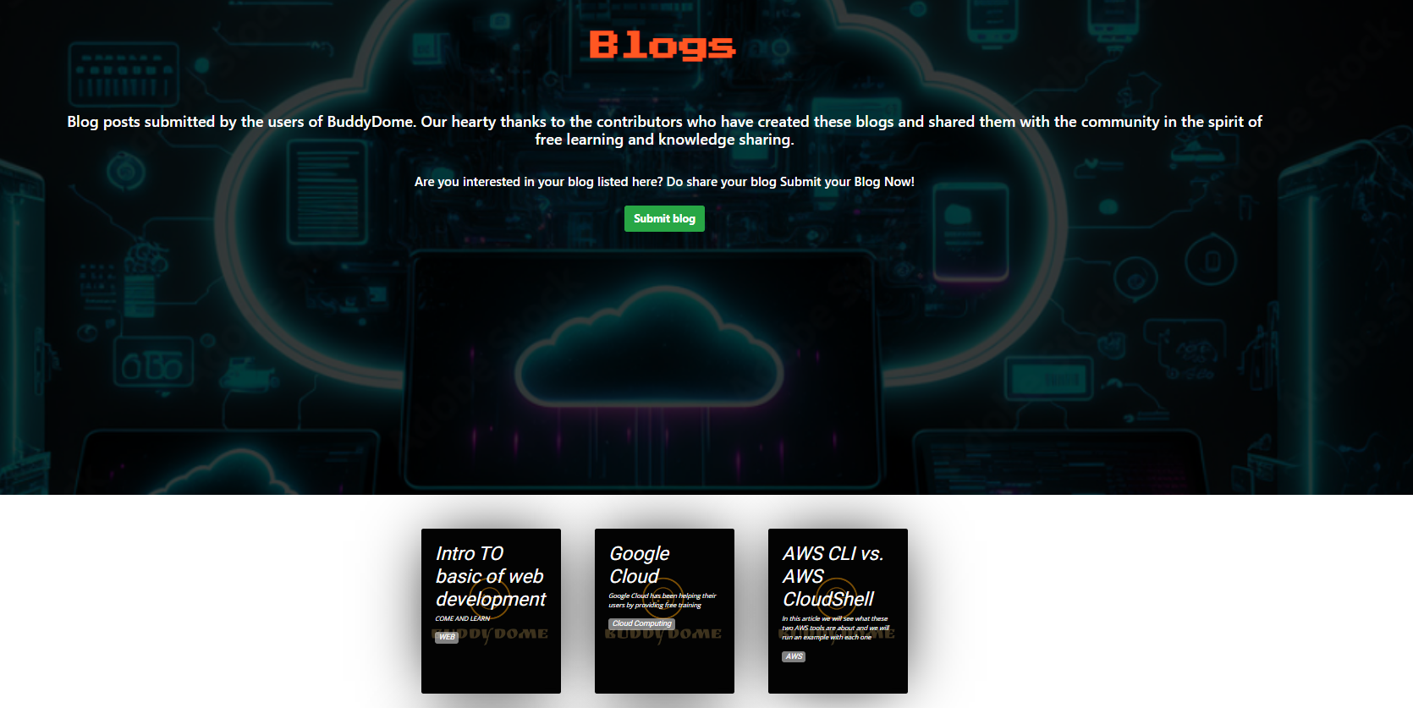

* Curriculum: A curriculum is a structured and comprehensive educational plan that outlines the course content and objectives of a learning program. A curriculum for a cloud study portal might include the following elements:

1. An introduction to cloud computing, its benefits, and its role in modern business and technology.
2. Fundamentals: A comprehensive overview of the fundamental concepts of cloud computing, including architecture, deployment models, and service models.
3. Cloud Providers: An in-depth study of the leading cloud providers, such as AWS, Microsoft Azure, and Google Cloud, and their respective services and offerings.
4. Security: A study of cloud security best practices, security protocols, and security tools for securing cloud environments.
5. Migration and Optimization: An exploration of cloud migration strategies and best practices, as well as techniques for optimizing cloud deployments for cost, performance, and scalability.
6. DevOps and Automation: A study of DevOps methodologies, tools, and best practices for automating cloud infrastructure and application deployment.
7. 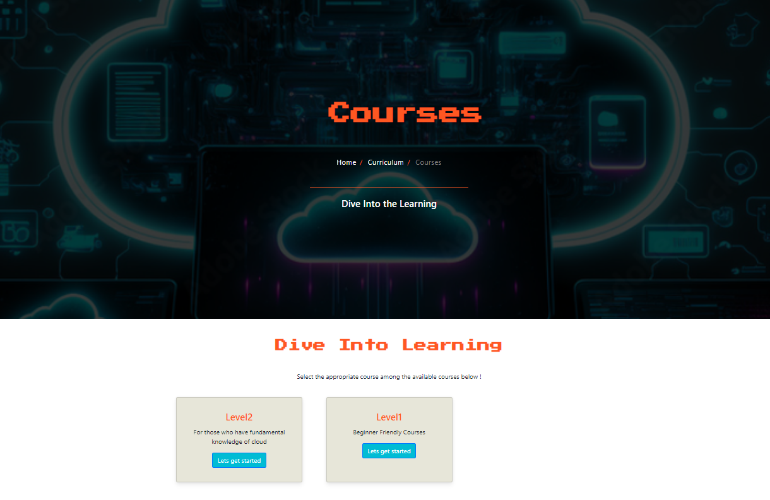Case studies: Real-world case studies that showcase

* Community:A community is a group of people who share common interests and goals and interact with each other in a social or professional setting. In the context of a study portal, a community can refer to:

1. User community: A group of users who are registered on the portal and interact with each other through features such as forums, discussion zones, and chat rooms.
2. Here user will be able to request for start course,request-course &community connect.

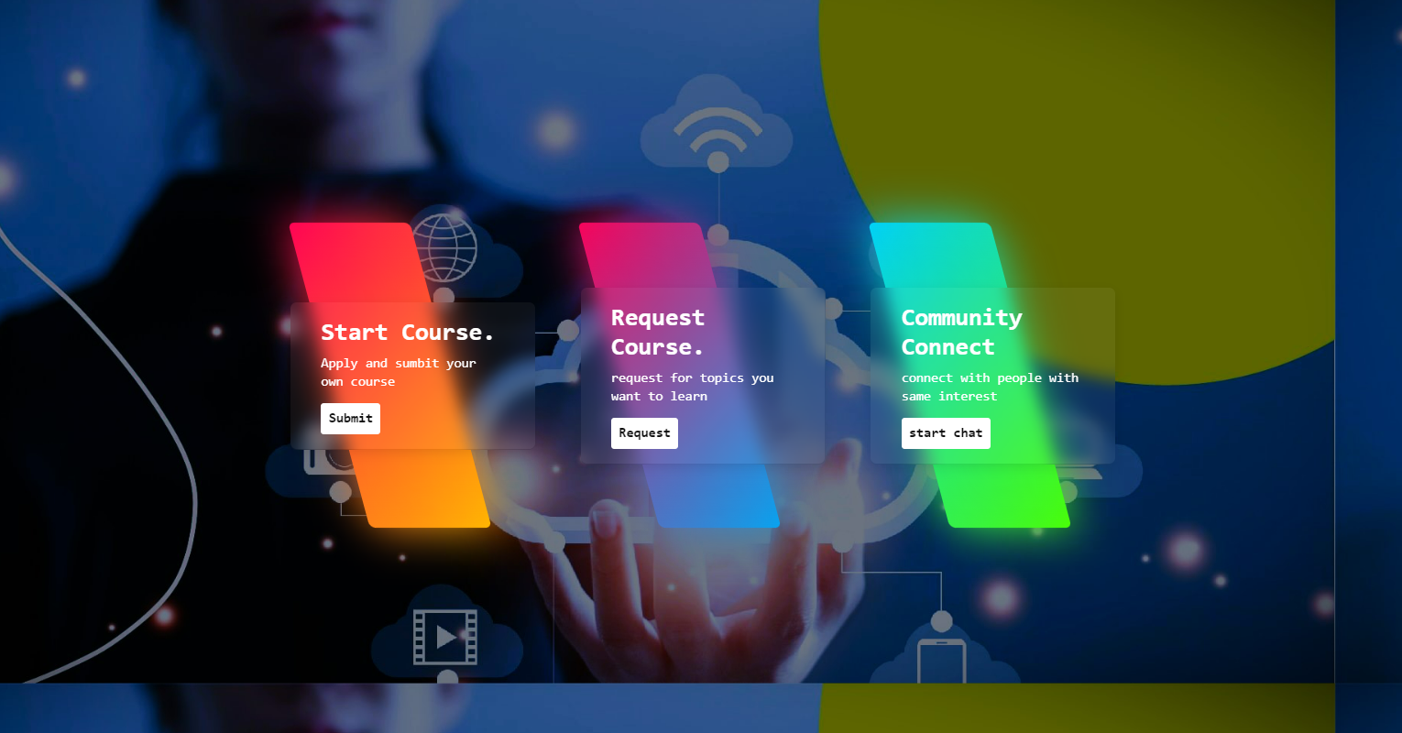

4.3 Subsystem services:

Subsystem services are individual components of a larger system that work together to achieve a common goal. In the context of our website subsystem services might include:

1. User management: A service that manages user accounts, authentication, and authorization.
2. Course management: A service that manages the courses offered on the portal, including course content, progress tracking, and certificate generation.
3. Learning management system (LMS): A service that tracks and manages the progress of users through the courses they are taking.
4. Content management system (CMS): A service that manages and organizes the content on the portal, including blog posts, articles, tutorials, and educational resources.
5. Analytics and reporting: A service that provides insights and analytics on user behavior and portal performance, allowing for continuous improvement and optimization.

Each of these subsystem services work together to provide a seamless and integrated learning experience for users on the cloud study portal.

4.4 System Designs

4.4.1 Architecture Diagram

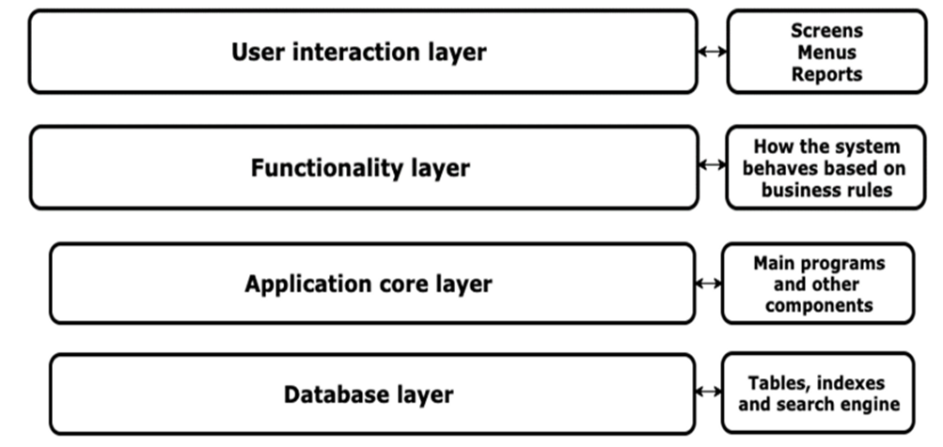

Fig 4.4.1

User Interaction layer-The UI layer is the pipeline that converts application data changes to a form that the UI can present and then displays it.The role of the UI is to display the application data on the screen and also to serve as the primary point of user interaction. Whenever the data changes, either due to user interaction (like pressing a button) or external input (like a network response), the UI should update to reflect those changes*.* Effectively, the UI is a visual representation of the application state as retrieved from the data layer. Static files consisting of images, CSS are rendered to AWS S3 bucket as illustrated below:

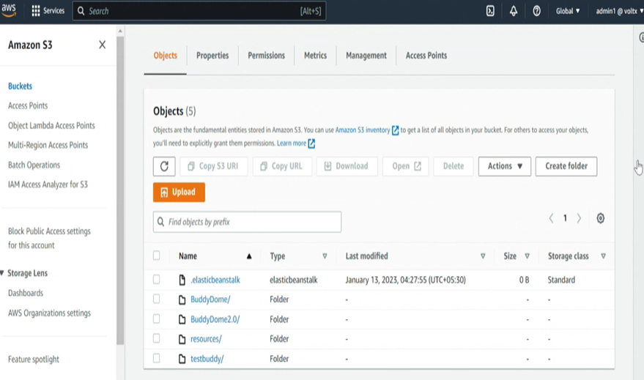

Functionality layer-This layer provides the standardized functions that allow various transport protocols to use any network device driver that is compatible with the specifications of this layer, providing both flexibility and reliability to developers.

Application layer- An application layer is a component within an application that determines how a network system operates and performs. The application layer is where users interact with the network, download information and send data. Understanding what the application layer is can help you learn how a network operates and determine the causes of an error if one arises. Connectivity with AWS cloud services, writing programs to connect our storage/ database to our application

Database layer-The database layer, which is also known as the data tier, stores all the information related to user profiles and transactions. Essentially, it contains any data that needs to persist in being stored in the data tier. In this project we have PostgreSQL which is used as the primary data store or data warehouse for many web, mobile, geospatial, and analytics applications.

4.4.2 Database Mechanism

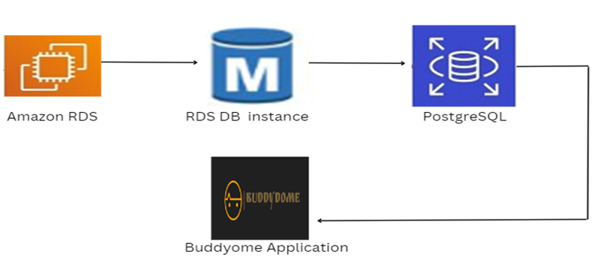

Fig 4.4.2

We are using amazon RDS to create a database instance of PostgreSQL database , so these are the properties of the database instance we are using, this is the instance class i.e the processor with the 1 gb of ram, now this is important, the endpoint or we can say the host, it is used

to connect to our Django application and the elastic beanstalk. We have already discussed security groups.With this we can look into the tables in a more detailed view without logging in the application as admin.

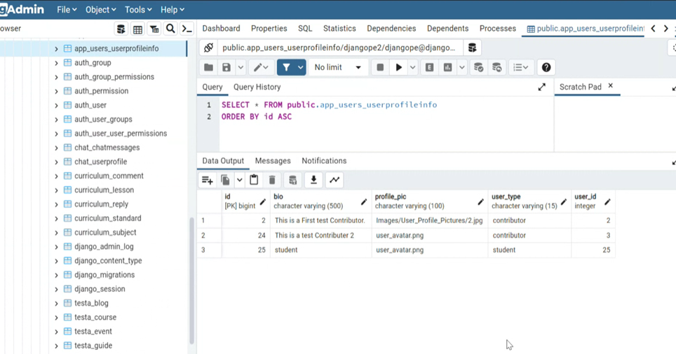

4.5 User Interface designs:

User interface design is the process of creating interfaces in software or computerized devices with a focus on looks or style and how a user interacts with it. It involves arranging elements such as text, graphics, buttons, and icons to make the product easy to use and enhance the user experience. Good UI design helps create a seamless and intuitive experience for the user, making it easier for them to perform desired actions

4.6 Summary:

Our website is an online platform where users can access and study course materials from the cloud. The user interface of a website is crucial in determining the user experience. A well-designed UI can provide a seamless and intuitive experience for the users, making it easy for them to navigate the platform, access course materials, and complete their studies. A good UI should be visually appealing, organized, and easy to use, with clear navigation and well-labeled buttons and icons. It should also be responsive and accessible, so that users can access the platform from any device and with ease. In summary, the UI of a study portal should be designed to provide a positive and productive user experience, making it easier for users to achieve their goals and complete their studies.

**CHAPTER 5: TECHNICAL IMPLEMENTATION & ANALYSIS**

5.1Outline:

The technical implementation and analysis of a cloud study platform involves several key components:

1. Architecture: The platform should be designed using a scalable and flexible architecture, allowing for the addition of new features and functionalities as needed. It should also be secure, with proper data encryption and backup measures in place to protect sensitive information.
2. Cloud hosting: Cloud hosting provides the platform with the necessary resources and infrastructure to support a large number of users, while also reducing costs and increasing reliability.
3. Content Delivery Network (CDN): A CDN is used to distribute content and resources to users, improving load times and ensuring that the platform is accessible from any location.
4. User Management: A robust user management system is necessary to keep track of users, their roles and permissions, and the courses they are enrolled in. It should also provide tools for tracking user progress and performance.
5. Analytics: Analytics and data tracking should be integrated into the platform to monitor user engagement, course completion rates, and other key metrics. This information can be used to make improvements and optimize the platform for better performance The technical implementation and analysis of a cloud study platform involves designing a scalable and secure architecture, utilizing cloud hosting and managing users.

5.2 Technical coding and code solutions:

1. models.py:

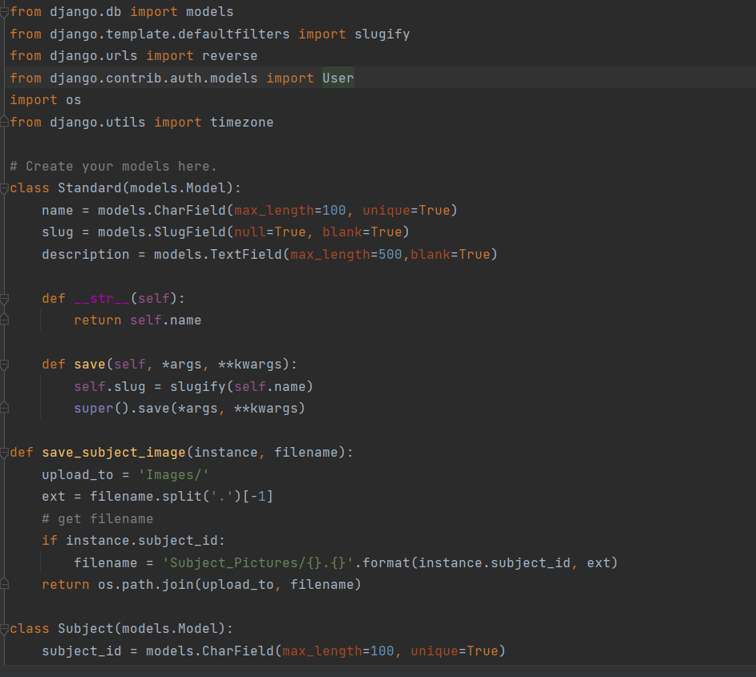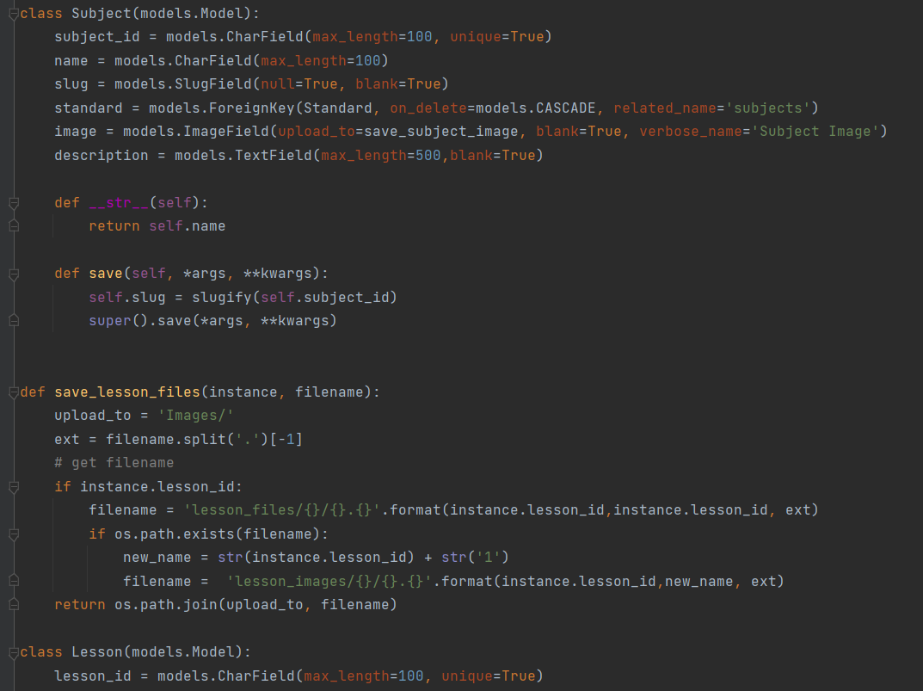

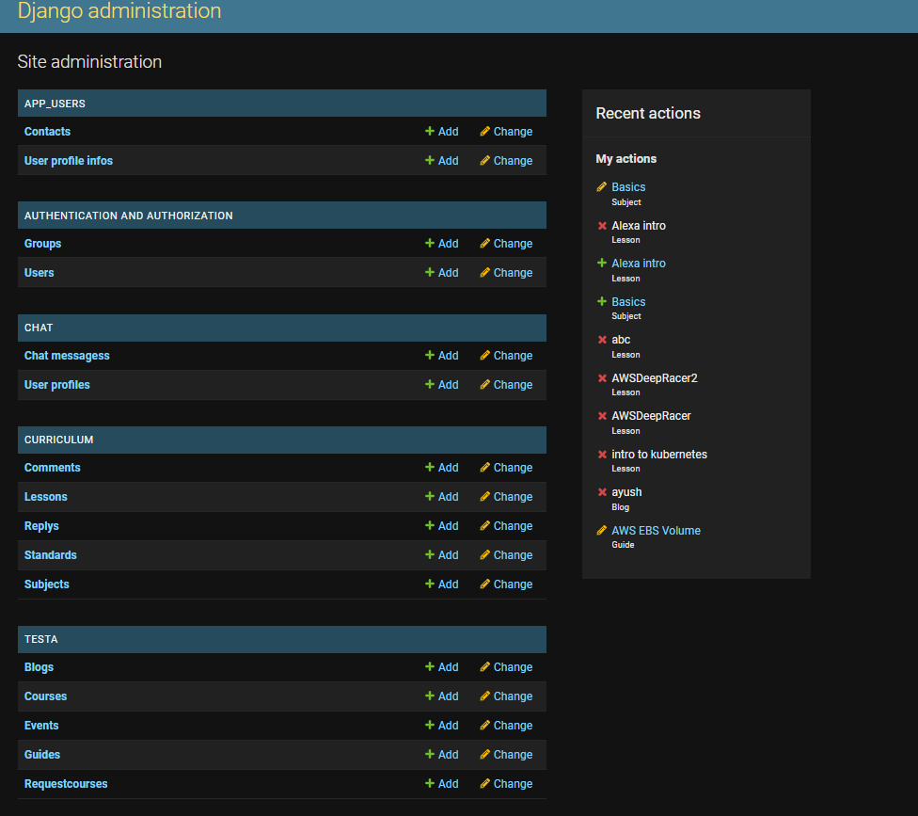

B.views.py:

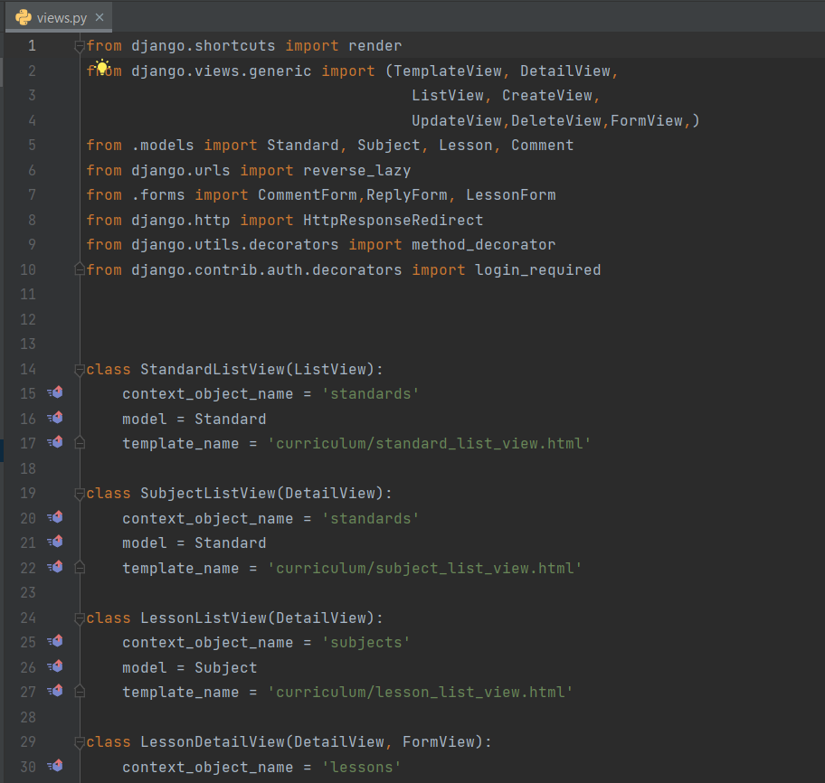

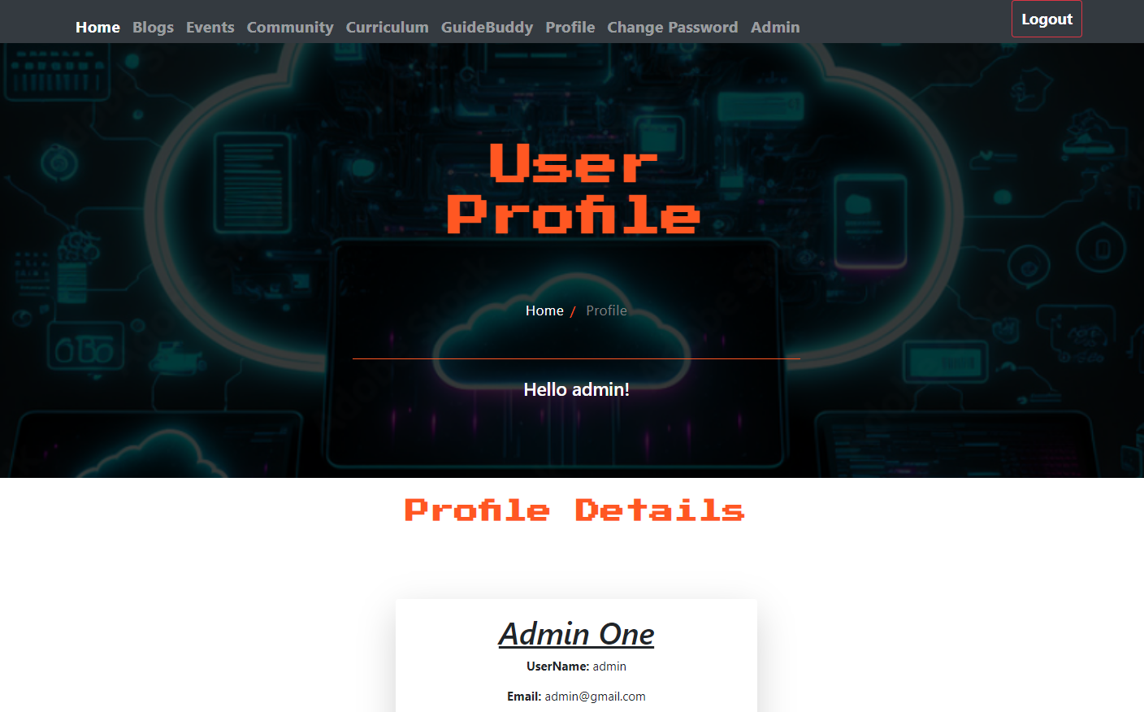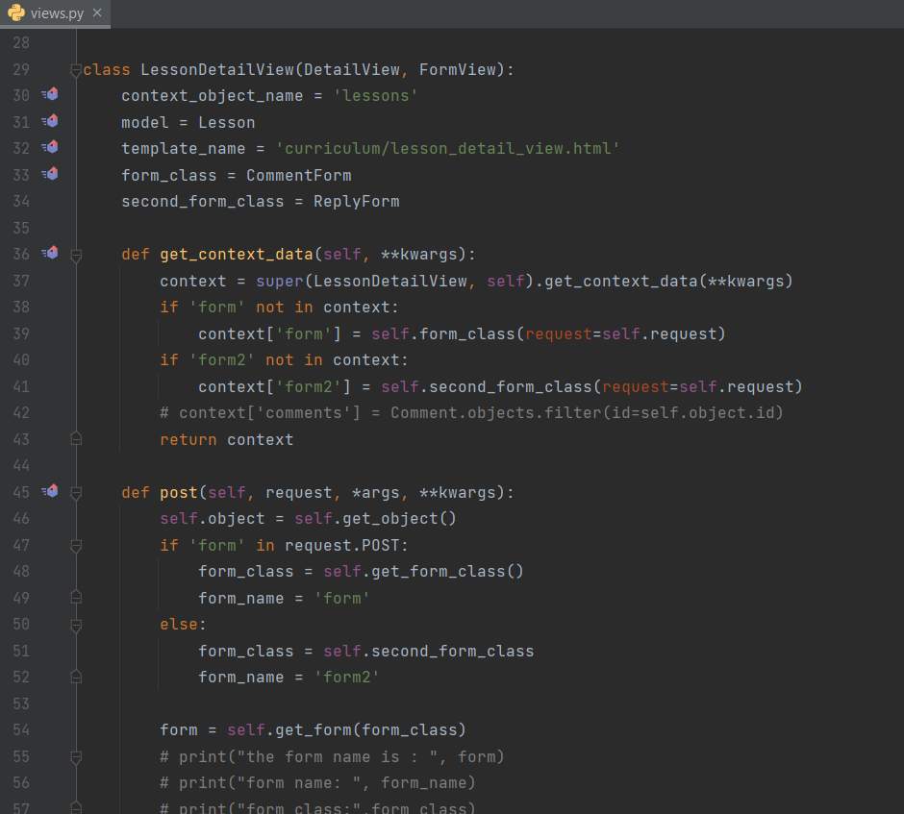

C.bs3.html:

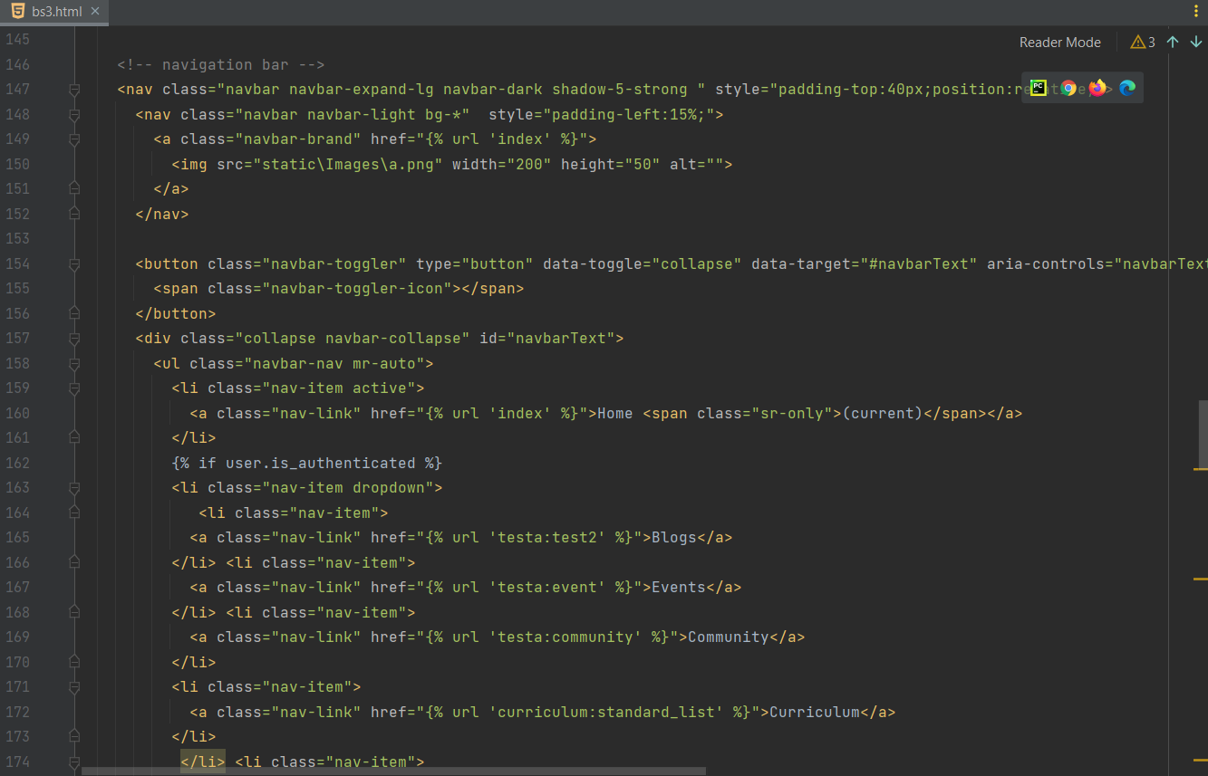

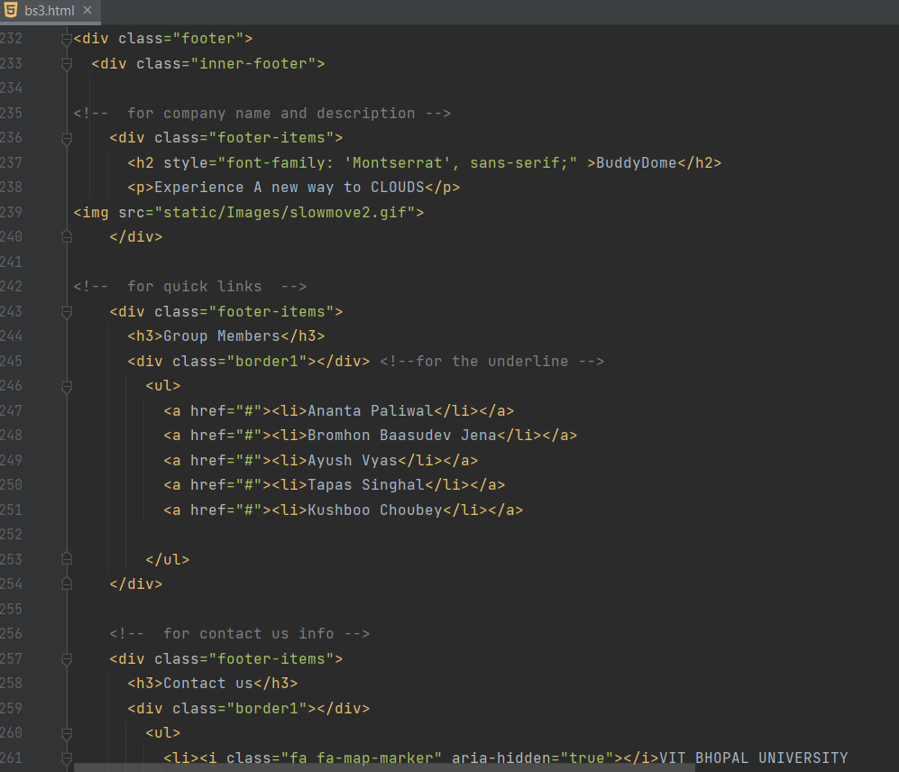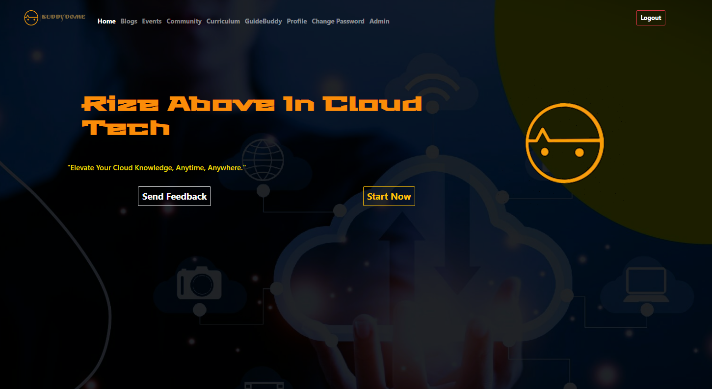

D.settings.py:

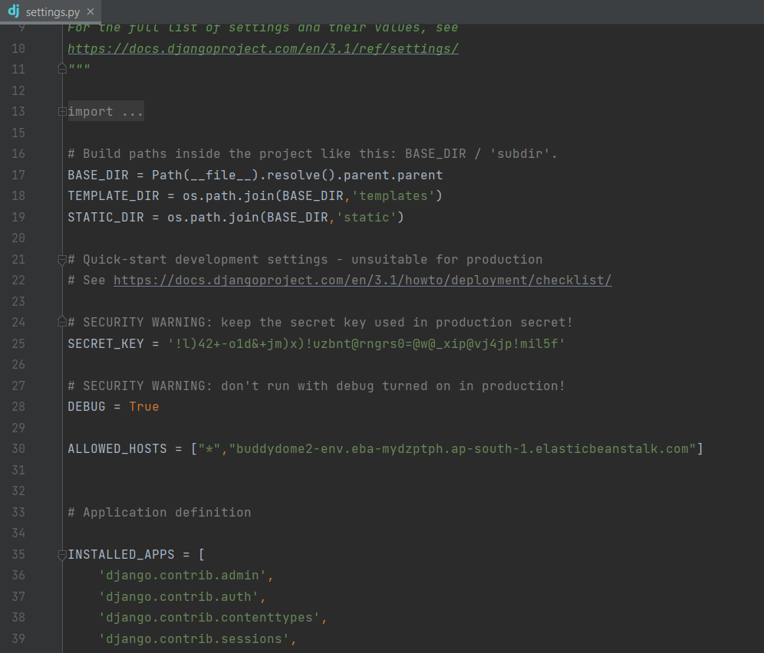

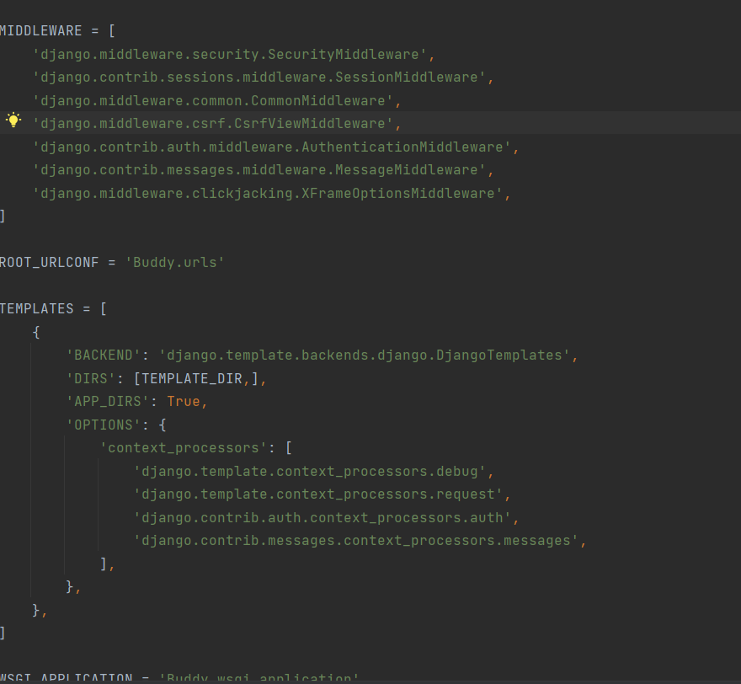

E.forms.py:

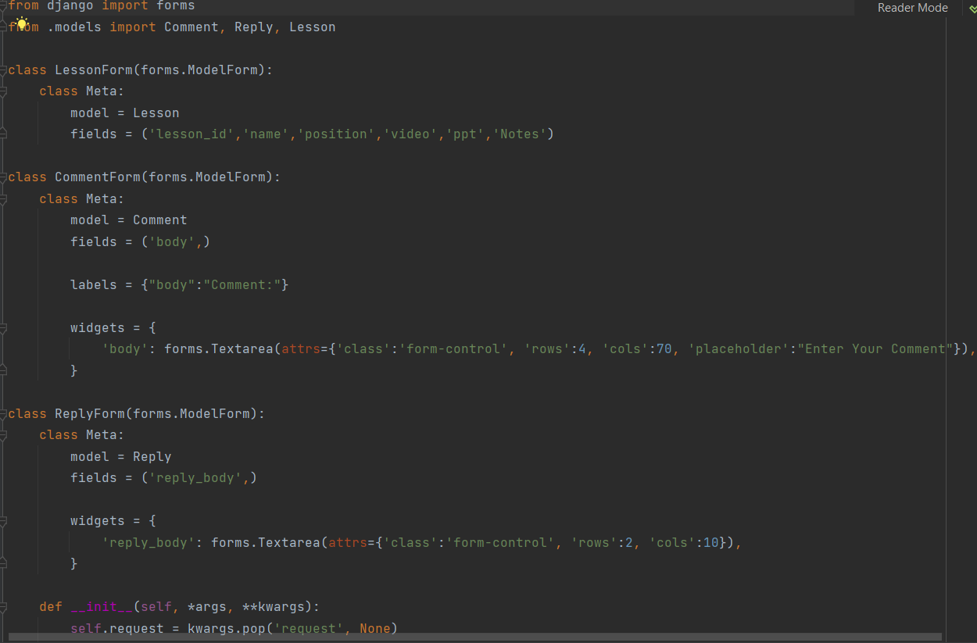

F:urls.py: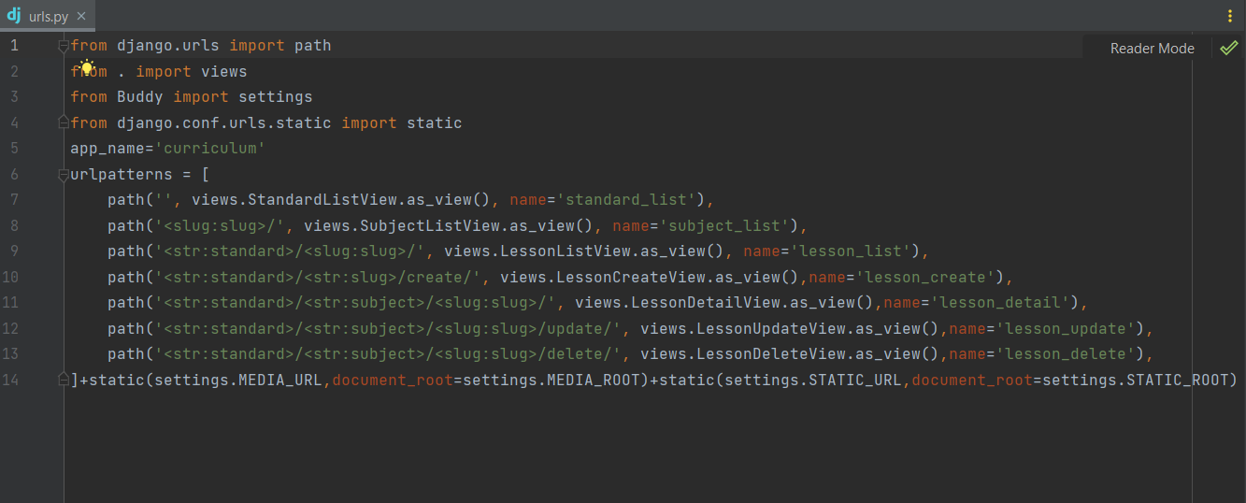

G. AWS Database solution

#settings.py

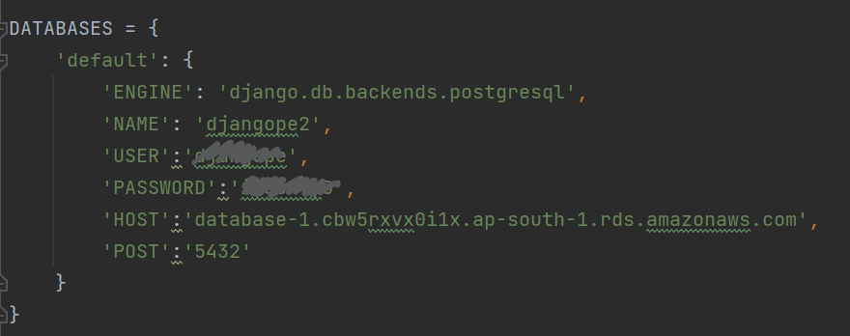

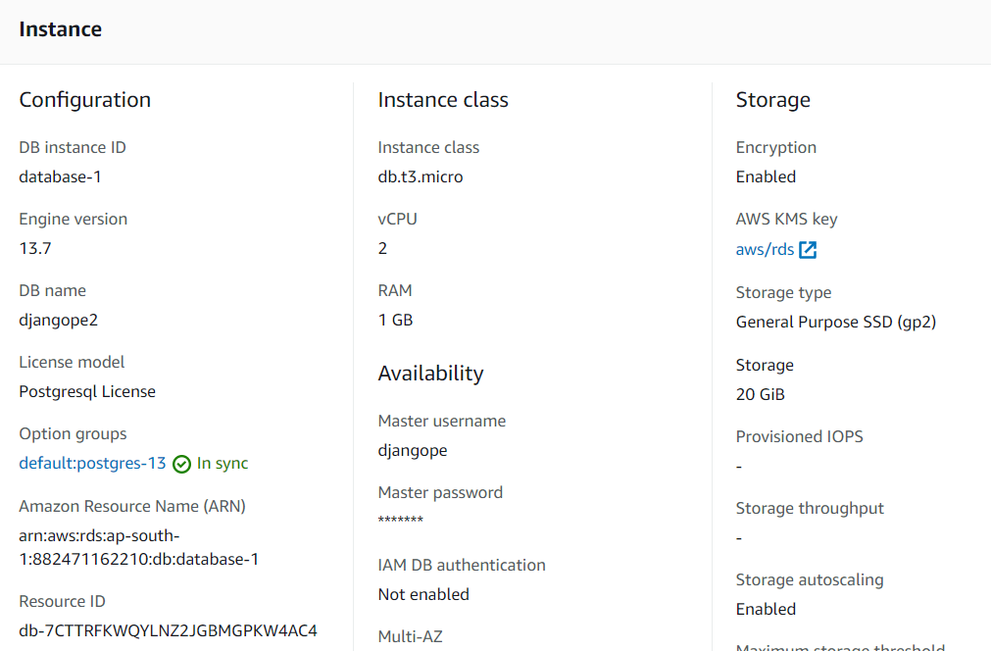

H. Elastic Beanstalk Scripts

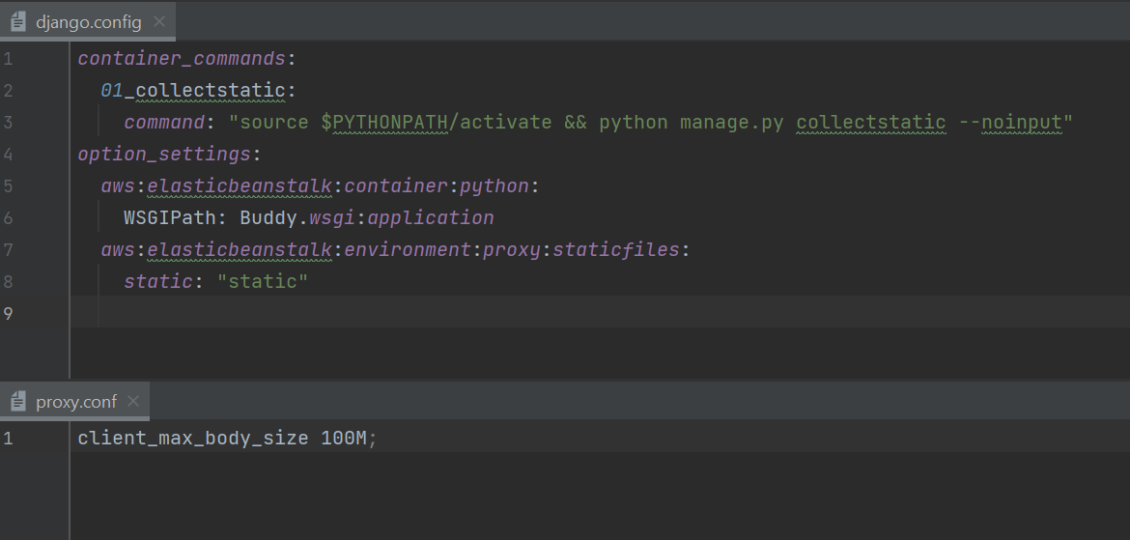

5.3.1 Data Flow Diagram

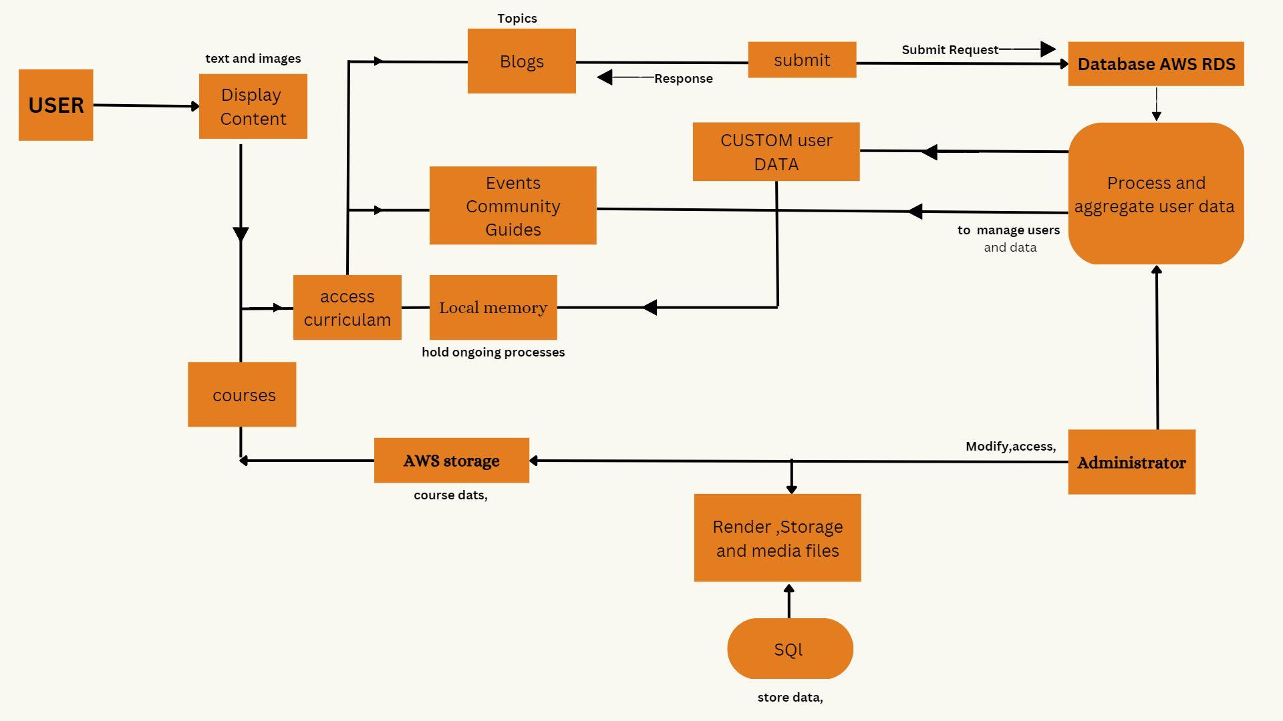

5.3.2 Class diagram

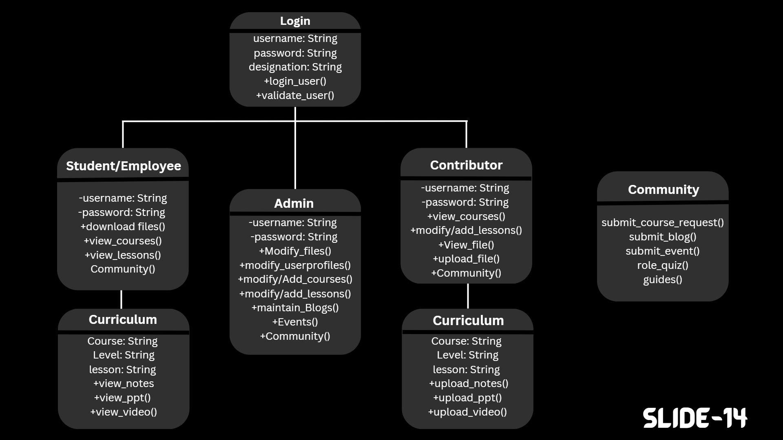

5.3.3 Process diagram

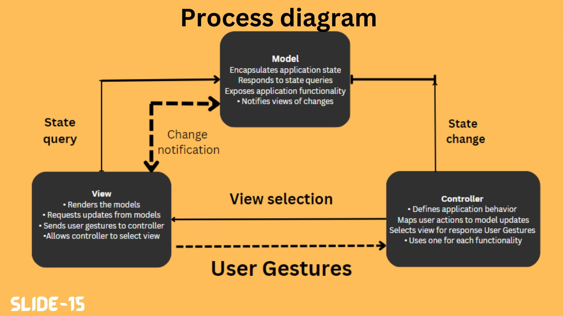

5.3.4 Cloud Migration

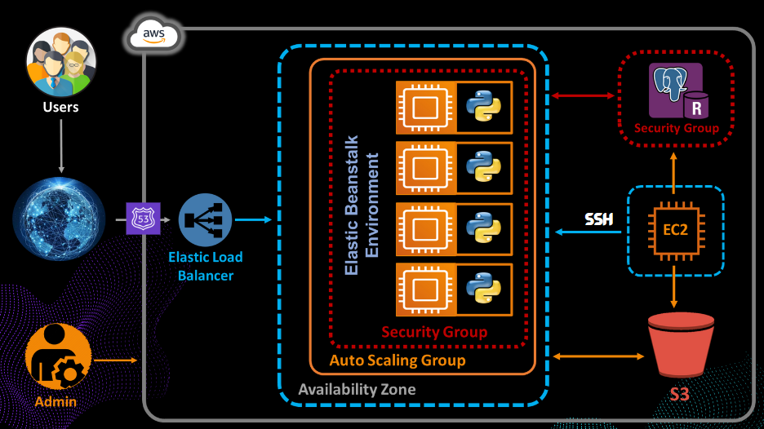

This section is about deployment of our application, and how we are using the AWS Cloud for hosting and managing purposes.

AWS infrastructure gives us many choices to deploy our application, the best practice is to use Elastic beanstalk, as instead of creating every instance individually and attaching a load balancer afterwards, Elastic beanstalk will take care of instances for us, it will handle the scaling instances based on the traffic, also terminates the instances automatically after the traffic minimizes, provides monitoring services like

its health or we can connect to external databases or a storage on a shared basis model easily with the help of elastic beanstalk.

So first of all, we have to create an python environment in Elastic Beanstalk for application as we have used Django as a backend framework, initially we deployed our first basic

version of our application in the environment and the elastic beanstalk will take care of the rest, and then we can use shh or cloud IDE like cloud9 for

further updating our project.

Now the static files, we are going to access the static files by writing some elastic beanstalk scripts to run some commands to collect all the static files and all the files will be saved in s3 bucket. And the media that is uploaded by the users can also be saved by writing the scripts, we have written a script to allow uploading files that are not more than 100Mb in size.

Next is the database connectivity, we are connecting a PostgreSQL database to our application using Amazon RDS, and after configuring some security groups like allowing TCP connections at port 8000 and this PostgreSQL 5432 port on all ivp4 addresses, additionally we can do all that in our Elastic beanstalk configuration section too.

Finally the last part is about DNS,to invoke our application using a domain we need a DNS resolver so we use Route 53 to create a hosted zone which is a collection of records that can be managed together belonging to a single parent domain i.e ‘**http://buddydome.cloud/**’ which points out to the url provided by elasticbeanstalk environment by creating a record of DNS ‘A’.

5.4 Performance Analysis:

Performance analysis for our website involves evaluating various aspects of the platform, including speed, reliability, scalability, security, and user experience. Here are some key areas to consider when conducting a performance analysis:

Speed and responsiveness: Users expect a fast and responsive platform, with quick load times and a smooth user experience. This can be measured through various tools such as website speed testing tools, which can provide insight into the platform's performance and identify areas for improvement.

Reliability: The platform should be available and functional at all times, with minimal downtime or technical issues. This can be monitored through various tools, such as uptime monitoring software, which can detect and alert administrators to any issues.

Scalability: The platform should be able to handle an increasing number of users and courses, with the ability to add resources and scale as needed. This can be tested through load testing, where the platform is subjected to increasing levels of traffic to determine its limits and identify any performance bottlenecks.

Security: The platform should be secure, with proper encryption and authentication measures in place to protect sensitive information and user data. This can be evaluated through regular security audits and vulnerability assessments.

User experience: The user experience is a critical component of the platform, and it should be evaluated through user testing and feedback. User satisfaction, ease of use, and the overall look and feel of the platform can all be assessed to determine areas for improvement.

5.5 Summary

In conclusion, For a cloud study portal involves evaluating various aspects of the platform to ensure that it is fast, reliable, scalable, secure, and provides a positive user experience. This can be done through various testing and evaluation methods, and through gathering feedback from users.

**CHAPTER-6:** **PROJECT OUTCOME AND APPLICABILITY**

6.1Outline:

Project Outcome: The outcome of our project should be a functional and user-friendly platform that meets the needs of students and educators. The platform should be scalable, secure, and easy to use, providing students with access to course materials, educational resources, and tools for tracking progress. The project outcome should also include a comprehensive performance analysis to ensure the platform is functioning optimally and provides a positive user experience.

* This website is applicable to a wide range of educational institutions, from primary and secondary schools to universities and continuing education programs. The platform can also be customized to meet the specific needs of different organizations, including online course delivery, blended learning programs, and distance education.

6.2 key implementations outlines of the System:

It have the unique features or benefits of our website that set it apart from others, such as user-friendly interface, comprehensive study materials, personalized learning experience, interactive tools and resources, etc. Additionally, you could also consider collecting feedback from users and incorporating it into your marketing message to showcase the positive impact our website has had on their life. The website have different kinds of user, event and course management types which makes the consumers hurdle free to explore on. Accessibility: The website should be accessible from any device, including laptops, tablets, and smartphones, and should be optimized for different screen sizes and resolutions.

6.3 Significant project outcomes:

The significant outcomes includes:

* Increased accessibility: The portal allows students and instructors to access educational materials and resources from anywhere with an internet connection.
* Improved collaboration: The portal enables students to work together on group projects and communicate with instructors and classmates in real-time.
* Enhanced organization: The portal provides a centralized location for all course materials, assignments, and grades, making it easier for students and instructors to keep track of their progress.
* Reduced costs: By storing and delivering educational materials through the cloud, institutions can lower the costs associated with physical textbooks and other resources.
* Increased engagement: The use of multimedia and interactive tools in the portal can enhance the overall learning experience and increase student engagement.
* Access to up-to-date resources: The cloud-based nature of the portal allows for easy updates and access to the latest educational materials and resources.

6.4 Project applicability on Real-world applications:

It has several real-world applications, including:

* Education: The portal can be used by educational institutions to provide students with online access to course materials, assignments, and assessments.
* Corporate training: Companies can use the portal to deliver training programs to employees, allowing them to learn at their own pace and from any location.
* Professional development: The portal can be used by organizations to provide on
* going training and development opportunities for their employees.Distance learning: The portal can be used by universities and colleges to deliver distance learning programs, allowing students to complete their studies from anywhere in the world.
* Exam preparation: The portal can be used by individuals preparing for certification exams or professional licensing tests.
* Continuing education: The portal can be used by individuals seeking to upgrade their skills or learn new ones in order to stay current in their field.
* Self-paced learning: The portal can be used by individuals seeking to learn new skills or knowledge on their own time and schedule.

6.5 Inference:

Inference refers to the process of using existing knowledge to make predictions or deductions about new data. In the context of a cloud study portal, inference could be used for several purposes, including:

* Personalized learning: By tracking students' progress and performance on assessments, the portal can use inference to identify areas where students may need additional support and tailor the learning experience to their individual needs.
* Predictive grading: The portal can use inference to analyze students' performance on previous assignments and predict their grades on future assignments, helping instructors to better assess their students' progress.
* Adaptive testing: The portal can use inference to adapt the difficulty level of assessments based on students' performance, providing a more personalized and challenging experience.
* Student behavior analysis: By tracking students' interactions with the portal, the platform can use inference to identify patterns in their behavior and learning habits, allowing instructors to better understand their students and adjust their teaching approach accordingly.
* Content recommendations: The portal can use inference to recommend additional resources and materials to students based on their interests and needs, enhancing their overall learning experience.

**CHAPTER-7:**

**CONCLUSIONS AND RECOMMENDATION**

7.1Outline:

Based on the benefits and applications our website have , the following conclusions and recommendations can be made:

Conclusions:

The website provides increased accessibility, improved collaboration, enhanced organization, reduced costs, increased engagement, and access to up-to-date resources.

The Website has a wide range of real-world applications, including education, corporate training, professional development, distance learning, exam preparation, continuing education, and self-paced learning.

Inference can be used for personalized learning, predictive grading, adaptive testing, student behavior analysis, and content recommendations.

Recommendations:

Educational institutions should consider implementing our unique website as part of their online learning strategy to enhance the student experience and improve educational outcomes.

Companies should consider using the portal for employee training and development programs to improve their overall performance and competitiveness.

Individuals seeking to learn new skills or knowledge should consider using the portal as a self-paced learning tool.

7.2 Limitation/Constraints of the System:

Our current website has certain limitations regarding the management of high users and massive reach to the audience. And to apply for a contributor we have no such special features now only the admin will assign the contributor on a personal level which will be difficult for massive responses. Currently user cannot track their progress they can only learn and view the cloud lessons or different things which makes the user sometimes confusing if they have not bookmarked or saved where they left on that particular lesson. The features and tools offered by Buddydome may not be fully customizable, limiting their ability to meet the specific needs of users. And as we know While cloud study portals can be more cost-effective than traditional study methods, they may still require a subscription or usage fee

7.3 Future Enhancements:

In the future upgrade, we will provide a proper tracking monitor and a progress bar for every user and by using the tracking monitor they can see how much they have completed and what goals are needed to achieve it. We will have a proper team to review any applications for contributors and doesn't have to be done by admin directly only.

1. Improved accessibility: Developing offline capabilities and better support for low-bandwidth environments can make our website more accessible to a wider range of users.
2. Enhanced security measures: Implementing stronger security measures, such as encryption and multi-factor authentication, can help to ensure the privacy and security of sensitive data.
3. Increased customization: Allowing users to tailor the interface and features to their specific needs and preferences can improve the overall user experience.
4. Integration with other tools: Integrating our website with other educational technologies, such as virtual and augmented reality tools, can enhance the learning experience.
5. Better analytics and reporting: Providing real-time insights and analytics on student performance and engagement can help educators to assess the effectiveness of their teaching methods
6. Multiway of Event Hosting, Project Sharing among all users and Team recruiter for projects.

7.4 Inference:

So, in the end our website will provide users with a unique experience to learn cloud and its essential with exploring many real life applications and learn through many events in progress to apply their knowledge to what they earn.

* Convenient access: Our website will allow users to access study materials from anywhere with an internet connection, making it easier to fit learning into busy schedules.
* Collaborative learning: It will facilitate collaboration between students, allowing for group discussions, shared resources, and feedback on projects.
* Cost-effective: In many cases, our BuddyDome will be way more affordable than traditional methods of learning, such as textbooks or in-person classes.
* Interactive and engaging: It can incorporate multimedia elements, such as videos, simulations, and gamification, to make learning more interactive and engaging.
* Personalized learning: BuddyDome can provide customized and adaptive learning experiences, tailoring the learning experience to the individual needs and pace of each student.
* Real-time feedback: We have instant feedback on assignments, quizzes, and tests, allowing students to learn and improve more quickly.